 CHEMICAL ENGINEERING TRANSACTIONS  VOL. xxx, 2025 | A publication of  
The Italian Association
of Chemical Engineering
Online at www.cetjournal.it

Guest Editors: Fabrizio Bezzo, Flavio Manenti, Gabriele Pannocchia, Almerinda di Benedetto
Copyright © 2025, AIDIC Servizi S.r.l.
ISBN 979-12-81206-17-5; ISSN 2283-9216

Wastewater treatment through microalgae cultivation: a pilot case study in Italy

Debora J. Magnaª, Alessia Foglia^{b*}, Maria Grazia Chietiª, Virginia G. Barros^{c}, Anna Laura Eusebi^{b}, Josue G. Camejo^{d}, Francesco Fatone^{b}

ª Department of Civil Engineering and Architecture, Faculty of Engineering – University of Catania, Catania (CT), Italy
^{b} Department of Science and Engineering of Materials, Environment and Urban Planning-SIMAU, Marche Polytechnic University, 60131, Ancona, Italy
^{c} Department of Civil Engineering - Santa Catarina State University (UDESC), Brazil
^{d} BETA Technological Center, Universitat de Vic-Universitat Central de Catalunya, 08500 Vic-Barcelona, Spain

*corresponding author: a.foglia@univpm.it
Microalgae-based treatment has been considered an ecological alternative that can contribute to face the consequences of climate change. Additionally, microalgae cultivation satisfies nutrient removal, promoting the circular economy and sustainable energy use. This study aims to evaluate the performance and the efficiency of nutrient abatement in a pilot scale plant based on microalgae in the real environment. The experimental activities are divided into three phases. Phase 1 was carried out to evaluate the efficiency of the removal of nutrients from the feeding of pre-settled municipal wastewater; Phase 2 was carried out to evaluate the performance of the pilot with the addition of sodium and Phase 3 was carried out to evaluate the efficiency of the removal of nutrients from the feeding of pre-settled municipal wastewater mixed with anaerobic rejected liquor from digestion. The removal efficiencies were 90% for ammoniacal nitrogen (N-NH₃) and 11% for phosphate phosphorus (P-PO₄) in phase 1, while they were equal to 99.36% for N-NH₃ and to 21.41% for P-PO₄ in phase 2. Phase 3 showed removal efficiencies of 50.54% for N-NH₃ and 1.3% for P-PO₄. Seasonal effects were observed and influenced removal efficiencies. Further studies should be carried out covering the annual period to validate and evaluate the results.
  - Introduction
Public health benefits significantly from wastewater treatment, which helps reduce disease outbreaks (Hughes et al., 2021). Additionally, these facilities play a key role in mitigating environmental pollution by removing pollutants such as organic matter, nitrogen, and phosphorus (Kan et al., 2021). Despite their critical importance to public health and environmental protection, wastewater treatment plants have also been identified as contributors to global warming due to their emissions of greenhouse gases (GHGs) such as carbon dioxide (CO₂), methane (CH₄), and nitrous oxide (N₂O) (Kan et al., 2021). Globally, wastewater management processes contribute approximately 1.57% of total greenhouse gas emissions (UN Environment Programme, 2023).
An innovative approach for the wastewater treatment sector involves adopting a circular economy model, which promotes the reuse and recycling of water (UN Environment Programme, 2023). In Italy, this concept is supported by legislative frameworks such as Ministerial Decree No. 185 of June 12, 2003, which establishes “Technical standards for wastewater reuse,” and Law Decree No. 39 of April 14, 2023, which outlines “Urgent measures to face water scarcity and enhance water infrastructure.” Moreover, the new Urban Wastewater Treatment Directive emphasizes stricter measures to monitor and reduce nutrient levels, such as nitrogen and phosphorus, in treated wastewater to minimize their environmental impact. It also prioritizes advanced treatment technologies and strategies to prevent nutrient pollution, thereby protecting water ecosystems and promoting sustainability. In this context, microalgae cultivation systems for wastewater treatment offer a sustainable solution for nutrient recovery and water recycling, aligning with regulations that promote circular economy practices in wastewater management. These systems, particularly those operating in open systems, offer several advantages, as noted by Gaurav et al. (2024). Key advantages include their low construction cost, reliance on sunlight for algal growth, ease of maintenance and natural gas exchange with the atmosphere, which releases oxygen. However, disadvantages include increased susceptibility to contamination by external organisms, limited control over environmental conditions and a high rate of water evaporation due to the system's design.
Microalgae-based wastewater treatment has gained attention because of its potential to absorb gases such as CO₂ and, in addition, microalgae have fast growth rates and high photosynthetic efficiency (Campos et al., 2016).
Research’s interest in microalgae-based effluent treatment has been steadily growing. For instance, Mantovani et al. (2020) investigated the use of microalgae for anaerobic rejected liquor treatment in a 1,200-liter outdoor raceway reactor pilot plant in northeastern Italy. Similarly, Vaz et al. (2023) conducted a comprehensive review of studies on the operation and performance of open-system microalgae-based effluent treatment reactors.
The increasing interest and numerous advantages of microalgae-based wastewater treatment systems are worth considering. This study aims to evaluate the efficiency of the removal of nutrients and to assess the performance of a pilot plant placed in a real environment.

2.Methodology
2.1 Pilot microalgae treatment plant
This study was carried out between January and July 2024, totalling 198 days of operation. It was developed through the Microalgae 4.0 project ((HORIZON-MSCA-2021-PF-01). The pilot plant operated in a real environment in a municipal wastewater treatment plant (WWTP) in Jesi, in central Italy. The microalgae reactor was fed with primary effluent from the WWTP. The primary effluent was transferred once or twice a week to a 1000 L tank (TK) and the microalgae reactor was fed by a peristaltic pump. The flow scheme of the pilot unit is shown in Figure 1.

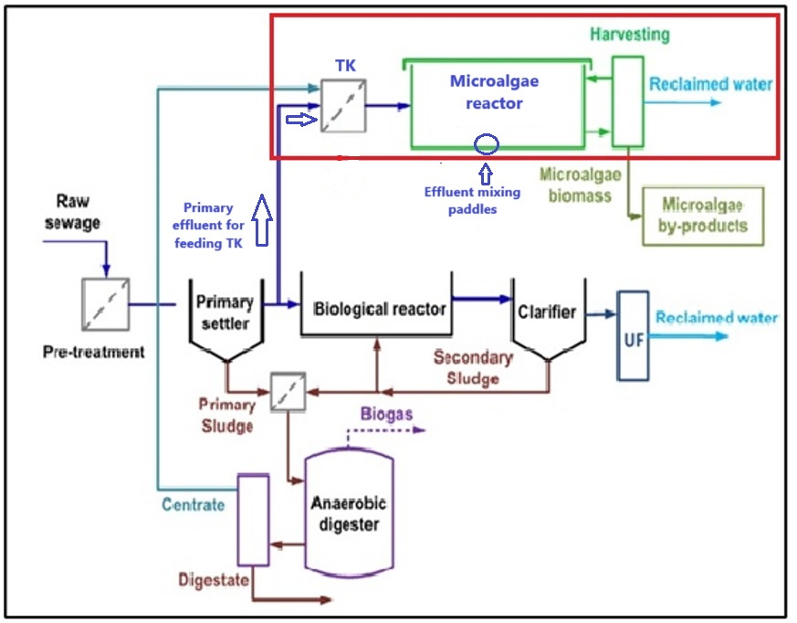
Figure 1 – Flow scheme of the microalgae-based pilot treatment system

The pilot project parameters are: a) total reactor volume: 125 L; b) reactor depth: 10 cm; c) length/width ratio: 5; d) hydraulic retention time (HRT) range: 2-5 d, corresponding to treatment flows of 25-63 L/d. Green microalgae was used in the project (Figure 2).
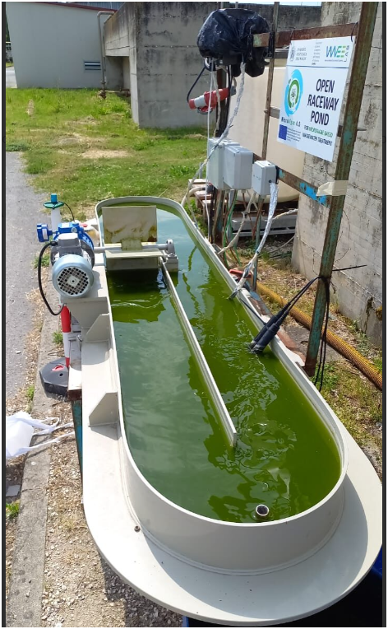
Figure 2 – Microalgae cultivation pilot reactor

2.2 Pilot plant operating conditions and study phases
Samples of the influent and effluent were taken once or twice a week to carry out the study, and were analysed in the water laboratory of the Università Politecnica delle Marche (Italy). The analysis of the parameters followed the international procedures (APHA, 2017), and were performed in duplicate. hydraulic retention time (HRT) during the study periods ranged from 1.4 to 6.7 days. Three study phases were carried out to analyse different operating conditions. In Phase 1, the pilot plant was fed with primary settled wastewater effluent from the full-scale wastewater treatment plant with flow rates ranging from 18.4 L/d to 91 L/d. The average influent concentrations were: pH = 7.72; N-NH₃ = 42.9 mg/L and P-PO₄ = 6.3 mg/L. The same matrix of Phase 1 was treated in Phase 2, 300 mg CaCO₃/L of sodium bicarbonate was added to the feed stream with flow rates that varied during the studying phase from 50 L/d to 75 L/d. The average influent concentrations in this second phase were: pH = 8.44, N-NH₃ = 17.15 mg/L and P-PO₄ = 6.63 mg/L. In Phase 3, the fed influent was composed as follows: 85% of pre-settled wastewater and 15% of anaerobic rejected liquor, for a total influent flow rate of 73 L/d. The average influent concentration values in this phase were as follows: pH = 7.95, N-NH₃ = 9.92 mg/L and P-PO₄ = 7.60 mg/L

  - Results and Discussion
3.1 Phase 1: pre-settled wastewater feeding
The results and removal efficiencies obtained during Phase 1 are presented in Table 1.
Table 1 - Average influent, effluent concentrations, and removal efficiency of Phase 1
Parameters | Influent (mg/L) | Effluent (mg/L) | Removal efficiency (%) | Average temperature (°C)
pH | 7.72± 0.1475 | 9.59±8.56 | - |  | 13,17
N-NH₃ | 42.9±6.63 | 4.3±4.22 | 89.9%
P-PO₄ | 6.3±0.82 | 5.6±0.433 | 11.1%

During the period studied between winter and early spring, the average effluent concentration of ammoniacal nitrogen was 4.3 mg/L. According to the Italian Ministerial Decree (DM) No. 185/2003, which regulates the reuse of wastewater, the limit value for ammoniacal nitrogen at the outlet of water recovery treatment plants is set at 2 mg NH₄/L. Therefore, the value is above the permitted limit in the legislation. In terms of removal efficiency, the ammoniacal nitrogen parameter reached a value of 89.9%.
The literature review conducted by Vaz et al. (2023) found removal efficiencies for ammonia and phosphate parameters of: 88.9-98% for N-NH₃ and 99.7-100% for P-PO₄.
Mohsenpour et al. (2021) provides a literature review on the removal efficiency values in high-rate algal ponds (suspended), as follows: Study 1: 79% for N-NH₃ and 22% for P-PO₄ with the following control parameters: temperature 13 °C and pH 9,7; Study 2: 99% for N-NH₃ and 94% for P-PO₄, with control parameters: temperature: 25 °C and pH 6,5 – 7,2.
Low nutrient removal efficiency were found by Mohsenpour et al. (2021) when temperature was 13°C and the pH was 9.7. This scenario is close to the values observed in our study, in which the average ambient temperature was 13.17°C and the pH was uncontrolled, varying between 7.72 and 9.59 (average inlet and outlet values).
The ideal range for the microalgae-based treatment, according Dinh et al. (2022) is between 15 and 25°C. The ideal temperature for the process to be efficient is 22°C (Mérida and Padrón, 2023), and it is known that the cultivation temperature had a direct influence on the uptake of nutrients by the microalgae.The pH control parameter may also have contributed to the low P-PO₄ removal efficiency. The ideal pH range for green algae would be between 7 and 8 (González-Camejo, 2019), which exceeded the range of our study, as a value of 9.59 was achieved. The growth rate of the microalgae did not significantly vary with pH ranging 6.5 and 8.5, a decrease is observed at higher pH values (Santos, 2017).
Light is a fundamental parameter in the microalgae system and is needed to synthesize molecules considered essential, including adhesonin triphosphate (Katam et al., 2022). In our pilot study, the incidence of light in the reactor was irregular, especially in the winter and spring months, when the reactor was in the shade for a longer period. González-Camejo (2019) mentions that the irregular incidence of light contributes to the limited growth of microalgae.

  - Phase 2: pre-settled wastewater feeding and sodium bicarbonate addition
In Phase 2, the results achieved can be seen in Table 2.
Table 2 - Average influent, effluent concentrations, and removal efficiency of Phase 2
Parameters | Influent (mg/L) | Effluent (mg/L) | Removal efficiency (%) | Average temperature (°C)
pH | 8.44±0.4685 | 10.51±0.62 | -
N-NH₃ | 17.15±7.04 | 0.11±0.25 | 99.36% |  | 19,34
P-PO₄ | 6.63±0.1473 | 5.21±0.613 | 21.41%

This phase was carried out by adding sodium bicarbonate to the feed stream and it took place during spring. The addition of sodium bicarbonate aimed to address the problem with the alkalinity of the culture medium.
During this period, the study showed better efficiency in removing ammoniacal nitrogen and a slight improvement in phosphate removal. As seen in Table 2, the average effluent concentration of ammoniacal nitrogen met the legal limit of 2 mg/L stipulated in DM No. 185/2003. However, for the pH parameter, the effluent concentration increased compared to Phase 1 and remained above the range stipulated by the mentioned DM, which is 6.0 – 9.5.
The addition of bicarbonate is considered an inorganic carbon source. As microalgae can absorb it due to their ability to interconvert it intracellularly and extracellularly (Latagan et al., 2024). However, its use causes the medium's pH to increase, as verified in this case study.
Tango et al. (2023), studied the growth of microalgae and nutrient absorption working with different nitrogen and phosphorus ratios (5:1, 10:1, and 20:1), with the addition of bicarbonate. Their results showed that for all three ratios, the ammoniacal nitrogen removal efficiency was above 95.97%±6.9%, reaching up to 100%. Regarding phosphate, the results varied across the three concentrations: 5:1 with a removal efficiency of -30.60%±162.25, 10:1 with a removal efficiency of 73.32%±21.78, and 20:1 with a removal efficiency of 98.33%±2.58.
The pH values observed in our study are higher than those obtained by Latagan et al. (2023). In addition to the pH parameter, the average temperature of 19.34 °C in this phase of the study remained slightly higher than in phase 1. However, Mérida and Padrón (2023) report that the ideal temperature for process efficiency in microalgae would be around 22 °C.
As in the previous phase, the uneven distribution of light in the reactor may still have contributed to the low removal of P-PO₄.
Although previous studies have obtained good phosphate removal efficiency, but not observed in this phase, the increase in pH, which favours CaCO₃ formation, sequestrating Ca²⁺ and reducing Ca₃(PO₄)₂ precipitation, coupled with low temperature, low natural light may have contributed to the P-PO₄ remaining low removal efficiency, although slightly better than that observed in phase 1.

3.3 Phase 3: pre-settled wastewater and anaerobic rejected liquor feeding
The results from Phase 3 can be seen in Table 3.
Table 3 - Average influent, effluent concentrations, and removal efficiency of Phase 3
Parameters | Influent (mg/L) | Effluent (mg/L) | Removal efficiency (%) | Average temperature (°C)
pH | 7.95±0.1105 | 9.68±0.77 | -
N-NH₃ | 9.92±0.0 | 4.56±0.0 | 50.54% |  | 26,214
P-PO₄ | 7.06±0.271 | 6.93±1.01 | 1.325%

Throughout this phase, approximately 15% of anaerobic rejected liquor (about 200 L) and 85% of primary effluent influent were added to the microalgae reactor to evaluate the system's performance. This period took place during the summer, with an average temperature of 26.214 °C.
Among the three phases of the study, this showed the lowest efficiency in the removal of ammoniacal nitrogen and phosphate. Both the pH and the ammoniacal nitrogen exceeded the legal limit established by DM n° 185/2003.
Mantovani et al. (2020) evaluated a microalgae-based wastewater treatment in the supernatant of blackwater dehydration. The average nutrient removal efficiency was 86%±7% for ammoniacal nitrogen and 71%±10% for phosphate The pH of the study was 8.2±0.3 and the temperature was 26 °C (August) and 17 °C (September).
The results presented in Table 3 show that the performance of this phase was below the results of Mantovani et al. (2020).
It was observed that at this stage of the study the external addition of carbon may have led to an imbalance in the system, i.e. the algae may have been stressed, which resulted in low nutrient removal efficiency. In addition, the very short study period made it difficult to evaluate the process.
For a better evaluation of this process, we suggest carrying out studies with different dosages of anaerobic reject liquor over a longer period of time.

CONCLUSION
The study showed that the microalgae-based wastewater treatment system can operate with different configurations, only treating urban wastewater or adding external sources of carbon and/or nutrients such as bicarbonate and anaerobic rejected liquor. To find the optimal operational parameters, a longer study period is necessary. Meanwhile, many scientific studies on this type of treatment have been conducted, which increasingly contribute to the knowledge of the best performances of the system. Furthermore, seasonal effects could be observed in the pilot nutrient efficiency.
However, this study had some limitations: a) the location of the pilot plant suffered, especially the microalgae reactor, from the shadow projection of one of the treatment tanks of the municipal wastewater treatment plant; b) the study periods were short, which made it difficult to understand the abiotic and biotic factors of the process; c) it is necessary to understand the metabolic relationships of the microalgae with the abiotic and biotic factors; d) improve the parameter control strategy by using probes with a greater number of parameters to ensure good process performance.
With the new European Directive on urban wastewater treatment, microalgae-based wastewater treatment has the potential to meet the objectives proposed in such legislation by adhering to the principles of the circular economy and the reuse of treated water.

ACKNOWLEDGMENTS
This work has been supported by the HORIZON MSCA Postdoctoral Fellowships Programme which funded “MicroAlgae 4.0” project under grant agreement 101067621. A kindly acknowledgment to VivaServizi for hosting the pilot plant on their premises.
REFERENCE
American Public Health Association (2017). Standard Methods for the Examination of Water and Wastewater. 23rd ed. Washington, D.C.: APHA.
Campos, J.L., Valenzuela-Heredia, D., Pedrouso, A. and Val del Río, A., 2016. Greenhouse Gases Emissions from Wastewater Treatment Plants: Minimization, Treatment, and Prevention. Journal of Chemistry, 2016(9), pp.1-12. Available at: http://dx.doi.org/10.1155/2016/3796352.
Dinh, N.T., Thu, L.P., Dat, N.T., Toan, N.K. and Ahn, P.L., 2022. The roles of microalgae and bacteria in wastewater treatment. Vietnam Journal of Biotechnology, 20(3), pp.573-588.
Gaurav, K., Neeti, K. and Singh, R., 2024. Microalgae-based biodiesel production and its challenges and future opportunities: A review. Green Technologies and Sustainability, 2. Available at: https://doi.org/10.1016/j.grets.2023.100060.
González-Camejo, J., 2019. Assessment of the flat-panel membrane photobioreactor technology for wastewater treatment: outdoor application to treat the effluent of an anaerobic membrane bioreactor. PhD thesis. Polytechnic University of Valencia.
Hughes, J., Cowper-Heays, K., Olesson, E., Bell, R. and Stroombergen, A., 2021. Impacts and implications of climate change on wastewater systems: A New Zealand perspective. Climate Risk Management, 31, 100262. Available at: https://doi.org/10.1016/j.crm.2020.100262.
Kan, C. et al., 2024. Wastewater treatment plant effluents increase the global warming potential in a subtropical urbanized river. Water Research, 266, p.122349. Available at: https://doi.org/10.1016/j.watres.2024.122349.
Latagan, M.J.D., Nagarajan, D., Huang, W.M., de Luna, M.D.G., Chen, J.H., Rollon, A.P. and Ng, I.S., 2024. Bicarbonate-based microalgal cultivation technologies: Mechanisms, critical strategies, and future perspectives. Chemical Engineering Journal, 502, p.157998. Available at: https://doi.org/10.1016/j.cej.2024.157998.
Mantovani, M., Marazzi, F., Fornaroli, R., Bellucci, M., Ficara, E. and Mezzanotte, V., 2020. Outdoor pilot-scale raceway as a microalgae-bacteria sidestream treatment in a WWTP. Science of The Total Environment, 710, p.135583. Available at: https://doi.org/10.1016/j.scitotenv.2019.135583.
Mérida, L.G.R. and Padrón, R.A.R., 2023. Application of microalgae in wastewater: opportunity for sustainable development. Frontiers in Environmental Science. Available at: https://doi.org/10.3389/fenvs.2023.1238640.
Ministerial Decree No. 185 of June 12, 2003. Regolamento recante norme tecniche per il riutilizzo delle acque reflue in attuazione dell'articolo 26, comma 2, del decreto legislativo 11 maggio 1999, n. 152. Gazzetta Ufficiale della Repubblica Italiana, 169, 23 July 2003. Available at: https://www.gazzettaufficiale.it/eli/id/2003/07/23/003G0210/sg.
Mohsenpour, S.F., Hennige, S., Willoughby, N., Adeloye, A.J. and Gutierrez, T., 2021. Integrating micro-algae into wastewater treatment: A review. Science of the Total Environment, 752, p.142168. Available at: https://doi.org/10.1016/j.scitotenv.2020.142168.
Santos, F.M.L.F., 2017. Crescimento de microalgas e remoção de nutrientes em ambientes poluídos com metais pesados. Mestrado integrado em engenharia do ambiente 2016/2017. Faculdade de Engenharia, Universidade do Porto.
Tango, M.D., Zanetoni Filho, J.A., Daniel, L.A., Leite, L.S., Hoffmann, M.T. and Moutinho, F.H.M., 2023. Effects of Bicarbonate Addition and N:P Ratio on Microalgae Growth and Resource Recovery from Domestic Wastewater. AgriEngineering, 5, pp.1178-1195. Available at: https://doi.org/10.3390/agriengineering5030075.
UN Environment Programme, 2023. Annual Report 2023. Nairobi: UNEP. Available at: https://www.unep.org/resources/annual-report-2023
Vaz, S.A., Badenes, S.M., Pinheiro, H.M. and Martins, R.C., 2023. Recent reports on domestic wastewater treatment using microalgae cultivation: Towards a circular economy. Environmental Technology & Innovation, 30, p.103107. Available at: https://doi.org/10.1016/j.eti.2023.103107.

